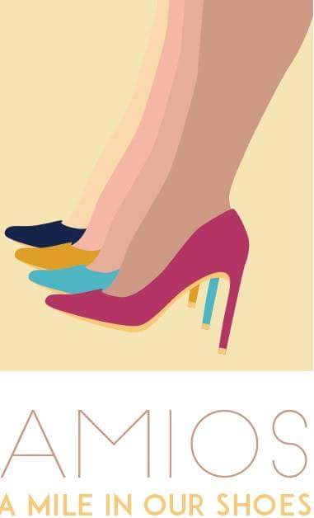
Call for Story Submissions

Story Submissions for A Mile in Our Shoes

The global book project ‘A Mile in Our Shoes’ is seeking submissions for stories of strength, inspiration, and empowerment from women across the globe. We aim to draw on your diverse life experiences and share them through our platform to create virtual bonds of support and solidarity for all women everywhere!

Being a global project, we welcome submissions from everywhere with unique personal experiences to share. All stories will be showcased on our website following a small review process. Selected submissions will be placed on our website and Facebook page.

Please use the following template to prepare your submissions and email them with this call for submissions to amiosbook@gmail.com.

SECTION I.
Author Details

Name
Organization (If any)
Title (Designation)
Email
Country of Origin

SECTION II.
Submission Details
- Please identify the geographic location of your submission concerns:
- Region/Province/State:
- Country:

2. Which of the following best describes your submission?
- Personal story/Sharing of life-changing experiences
- A specific challenge/misconception related to a gender issue
- A specific challenge facing women that you have addressed/or are addressing through your work

SECTION III.
Guidelines for Submission
While we appreciate and acknowledge unique and different writing styles, please follow the guidelines for all story submissions.

- Language: All types of submissions must be developed in clear and coherent English.

- Prompts: Please consider the following points when shaping your submission.

What is the message that you want to send to the women around the world? We would love to hear about the challenges that have shaped you, your inspirations that have driven you to strive and succeed and the most important message that you would like to give to all the readers. Please provide less details on your personal and professional achievements in the format of a resume and put more emphasis on the life experiences that have changed you.

Some prompts that can help in writing:
- Whom do I want to inspire with my story? What is my target audience?
- What is my main goal?
- What issues would I like to tackle?
- What is the situation of women in my country/local society? What are the traditions in my country/social society that affect a woman’s life? What are the challenges that they are facing nowadays? How did this situation affect me?
- How/From what perspective would I like to present myself and tell my story?
- What is the time frame of my story? How much time elapses between the beginning and the end of the story?
- What obstacles/challenges/misfortunes did I face? What was my biggest concern? What was the moment I realized I really wanted to change something (myself, my situation, my community, my society, etc.)? What were the steps I took that led me to success?
- How have my personal experiences and life opportunities helped shape my being? How did I feel in the beginning of the story? How did I feel by the end? How did I change throughout the story?

3. Technical Requirements for maintenance of quality:

For written submissions: Please ensure that a limit of 2,000 - 5,000 words is followed.
All written submissions must be in electronic format submitted in Microsoft Word or other readable/accessible format. Please also submit a small picture of yourself so we can add it with your story. High resolution is preferred.

For photo submissions: Storytelling through pictures is different, a little challenging but adept at capturing your inspirations and life experiences! To get a clear story from pictures, we request you to follow the guidelines specified below:

- Put a short description/a story at the end of each picture stating what the image is about
- Put up pictures which are shot at different locations and from different angles (i.e The side, behind, in front, through a door/window, below, above etc).
- Align the pictures in such a way that they show a beginning, middle and end just like any other story!
- Keep the pictures to a limited amount. Please keep in mind that other readers will not have time to look through everything if they are too many.
- Keep in mind both picture composition and natural lighting, these will make your photo more appealing.

Please ensure that photos do not contain any sexually explicit, obscene, nude or inappropriate/objectionable content.

Photos can be submitted in any format: JPEG, jpg, png form and must not be larger than 5MB per picture.

3. For video submissions: Submissions through video are a powerful medium for generating reader content and can really capture your experiences. To receive high quality submissions, we request you to follow the guidelines specified below:

- Please focus/position the video camera in such a way that it records you at approximately waist level. We will crop where required.
- Keep delivery clear; speak clearly making eye contact with the camera and with adequate volume (no shouting, but a strong voice).
- Please try to shoot the video against a white/single color background if possible with image stability. While using a tripod is excellent, ensure that the camera operator maintains a still position while recording.
- Quality of the video matters to assure maximum impact thus please ensure that a good resolution is present with lighting/darkness considerations. A high definition video is 1920 x 1080.

To send us your video, please connect the camera to your computer and using your camera’s software (which you should have installed on your computer) save the file as an .MP4, .MPEG, .AVI or .MOV file (your software should have any or all of these options). Please note that video files should not be larger than 200MB.

4. For audio submissions: Audio stories can be as captivating as video submissions! To ensure that your words capture the essence of your story, we request you to follow the guidelines specified below:
- Ensure that you speak slowly and clearly using adequate pitches to highlight the high and low-points in your story.
- Ensure there is absolutely no interruption/static when recording your story so listeners can fully be engaged.
- Quality of the audio file matters so please ensure that the delivery is as good as possible.

Audio files need to be submitted in the .MP3 or .WAV format with file size no larger than 200MB.

Intellectual Property Ownership and Permissions
You retain copyright ownership in your submitted materials. By entering a submission, you represent and warrant that you have have all rights and permissions necessary for your submitted materials (including all rights necessary to incorporate any third party content). We reserve the right to verify the ownership and originality of any submission. If required, you hereby agree to submit proof of ownership or any release, license or permission received from a third party granting you the right to use content, images, videos, likenesses in your submission.

